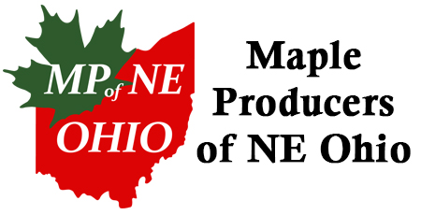
2019 Membership

Name
Address City
County State Zip Code
Email Phone:
Website
Sugar Bush or Company Name
Source of Collection: Buckets __________ Bags __________ Tubing __________ # of Taps __________
Do you want your name, address, email, phone number included on our website page? Yes_____ No______
Membership Fees:
€ $50 Producer 200 + Taps
€ $25 Producer 1-199 Taps

€ $25 Friends of Maple (Interested in supporting the Maple Industry)

$_______ Donation

Please make checks payable to MPNEO (Maple Producers of NE Ohio) and return your payment with this form to:
Maple Producers of NE Ohio
c/o Dee Belew, Secretary
17098 Messenger Road
Auburn Township, OH 44023
440-785-6877 ~ mcfbelew@aol.com

Mission Statement
Maple Producers of NE Ohio are dedicated to the production of quality maple syrup products through the education of the producers and public using proper forest management, stewardship and latest technology and techniques while still preserving the maple heritage.

